<https://www.figma.com/design/6dv9MNrWQ66AqhZfDVcqOr/Expense-tracker?node-id=0-1&t=rGLlnYgXvAPfnmIH-1>

Landing page;  
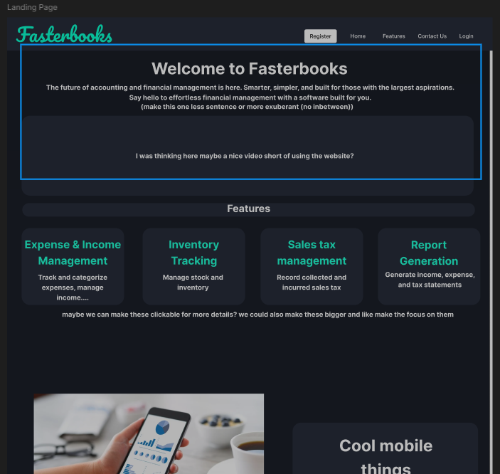

Logins:  
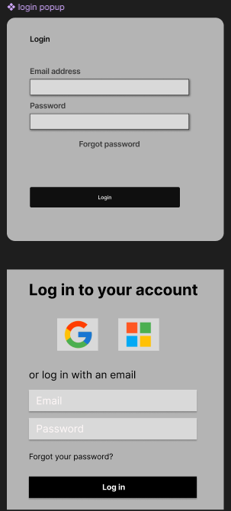

Feature pages:  
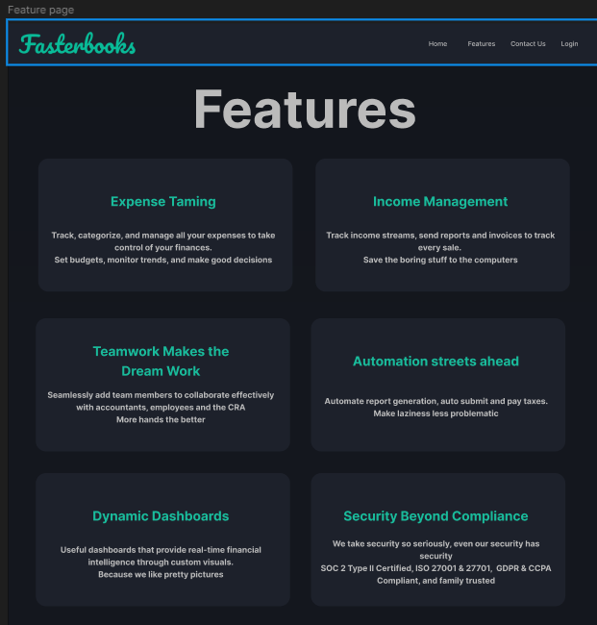

User dashboard:  
